BUS 203 Midterm Exam DUE FRIDAY 10/26 at 10:10 am in class

NAME:______________________________ ID:__________________________
Problems (80%)
Chapter 2
Problem 1 Remember to show all work and briefly discuss your results.
The following data set shows the number of hours of sick leave that some of the employees of Bastien's, Inc. have taken during the first quarter of the year (rounded to the nearest hour).
19 | 22 | 27 | 24 | 28 | 12
23 | 47 | 11 | 55 | 25 | 42
36 | 25 | 34 | 16 | 45 | 49
12 | 20 | 28 | 29 | 21 | 10
59 | 39 | 48 | 32 | 40 | 31

a. | Develop a frequency distribution for the above data.
  Class Interval | Frequency
  10-19 | 6
  20-29 | 11
  30-39 | 5
  40-49 | 6
  50-59 | 2
  Total | 30
b. | Develop a relative frequency distribution and a percent frequency distribution for the data.
  Class Interval | Frequency | Relative frequency Distribution | Percentage
  10-19 | 6 | 6/30 = 0.200 | 20%
  20-29 | 11 | 11/30 = 0.3667 | 36.67%
  30-39 | 5 | 5/30 = 0.1667 | 16.67%
  40-49 | 6 | 6/30 = 0.200 | 20%
  50-59 | 2 | 2/30 = 0.0667 | 6.67%
  Total | 30 |  | 100%
c. | Develop a cumulative frequency distribution.
  Class Interval | Frequency | Cumulative frequency
  10-19 | 6 | 6
  20-29 | 11 | 6+11 = 17
  30-39 | 5 | 6+11+5 = 22
  40-49 | 6 | 6+11+5+6 = 28
  50-59 | 2 | 6+11+5+6+2 = 30
  Total | 30
D. How many employees have taken less than 40 hours of sick leave?
22 employees have taken less than 40 hrs of sick leave.

e. Draw a histogram and discuss the skew, this may be drawn by hand.

Considering the shape of the histogram, it can be deduced that the data is skewed to the right.

Chapter 3:
Problem 2 Remember to show all work and briefly discuss your results.
A sample of charge accounts at a local drug store revealed the following frequency distribution of unpaid balances.
Unpaid Balance | Frequency
10 - 29 | 1
30 - 49 | 6
50 - 69 | 9
70 - 89 | 11
90 - 109 | 13
​
a. | Determine the mean unpaid balance.
  Unpaid Balance | midpoint (m) | Frequency (f) | m*f
  10-29 | 19.5 | 1 | 19.5
  30-49 | 39.5 | 6 | 237
  50-69 | 59.5 | 9 | 535.5
  70-89 | 79.5 | 11 | 874.5
  90-109 | 99.5 | 13 | 1293.5
   | Total | 40 | 2960
  Mean = (∑m*f)/n |  | 2960/40 | 74
b. | Determine the variance.
  Unpaid Balance | midpoint (m) | Frequency (f) | m*f | (m-mean)^2 | f*(m-mean)^2
  10-29 | 19.5 | 1 | 19.5 | 2970.25 | 2970.25
  30-49 | 39.5 | 6 | 237 | 1190.25 | 7141.5
  50-69 | 59.5 | 9 | 535.5 | 210.25 | 1892.25
  70-89 | 79.5 | 11 | 874.5 | 30.25 | 332.75
  90-109 | 99.5 | 13 | 1293.5 | 650.25 | 8453.25
   | Total | 40 | 2960 | 5051.25 | 20790
  Mean = (∑m*f)/n |  | 2960/40 | 74
  Variance = ∑(X-μ)^2/N |  | 20790/40 | 519.75
c. | Determine the standard deviation.
  Unpaid Balance | midpoint (m) | Frequency (f) | m*f | (m-mean)^2 | f*(m-mean)^2
  10-29 | 19.5 | 1 | 19.5 | 2970.25 | 2970.25
  30-49 | 39.5 | 6 | 237 | 1190.25 | 7141.5
  50-69 | 59.5 | 9 | 535.5 | 210.25 | 1892.25
  70-89 | 79.5 | 11 | 874.5 | 30.25 | 332.75
  90-109 | 99.5 | 13 | 1293.5 | 650.25 | 8453.25
   | Total | 40 | 2960 | 5051.25 | 20790
  Mean = (∑m*f)/n |  | 2960/40 | 74
  Variance = ∑(X-μ)^2/N |  | 20790/40 | 519.75
  Standard deviation = square root of variance |  | √519.75 | 22.8
d. | Discuss what parts a-c and what your results represent.  In part (a), the mean presents the average number of the of the unpaid balance spread  Over the members who have not paid. The variance shows how the data is spread from  The mean and in this case, our variance is 519.75. The use of the standard deviation  Measures the spread of data from average mean which for our data is 22.8

--------------------------------------------------------------------------------------------------------
Problem 3: Remember to show all work and briefly discuss your results.
The Michael Painting Company has purchased paint from several suppliers. The purchase price per gallon and the number of gallons purchased are shown below.
Supplier | Price Per Gallon ($) | Number of Gallons
A | 23 | 700
B | 25 | 200
C | 29 | 100
D | 27 | 200
Compute the weighted average price per gallon. Discuss the importance of the weighed average and how it is used.
Weighted average =( ∑w₁x₂) /∑w₂
= [(700)(23)+(200)(25)+(100)(29) + (200)(27)]/[(700+200+100+200)]
= 29400/1200
= 24.5
Using the weighted average method, each observation is assigned a weight before summing to a single average value. The weight assigned to each data set is used to determine the relative importance of each quantity.

-------------------------------------------------------------------------------------------------------------------
Chapter 7
Problem 4 Remember to show all work and briefly discuss your results. Sketch and shade region(s)

The life expectancy of computer terminals is normally distributed with a mean of 4 years and a standard deviation of 10 months.
a. | What is the probability that a randomly selected terminal will last more than 5 years?  P(X>5) = P(Z>(5-4)/0.833) =P(Z>1.205)  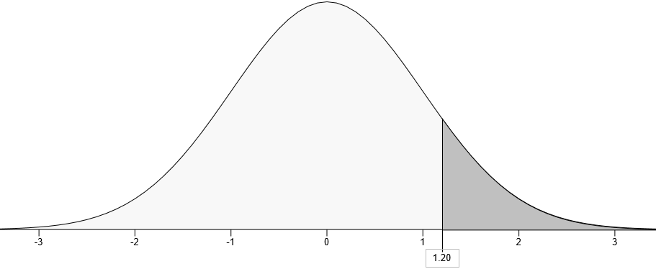  = 1-P(Z<1.205)  = 1-0.8859  = 0.1141
b. | What percentage of terminals will last between 5 and 6 years?  P(<X<6) = P((5-4)/0.833)<(X-μ)/σ < (6-4)/0.833)  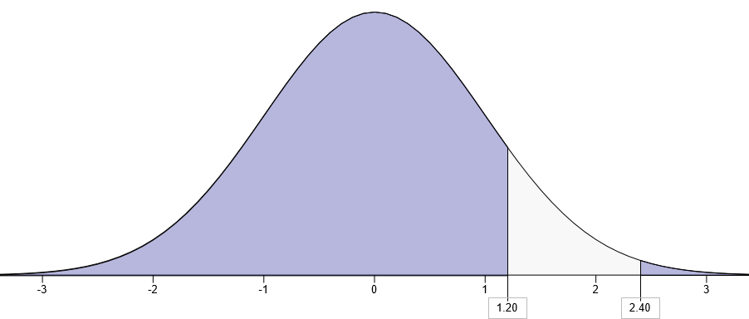  = P(1.205<Z<2.4096)  =P(Z<2.4096)-P(Z<1.205)  = 0.9920-0.8859 (From Z table)  = 0.1061  = 10.61%
c. | What percentage of terminals will last less than 4 years?  P(X<4) = P(X<(4-4)/0.833) =P(Z<0)  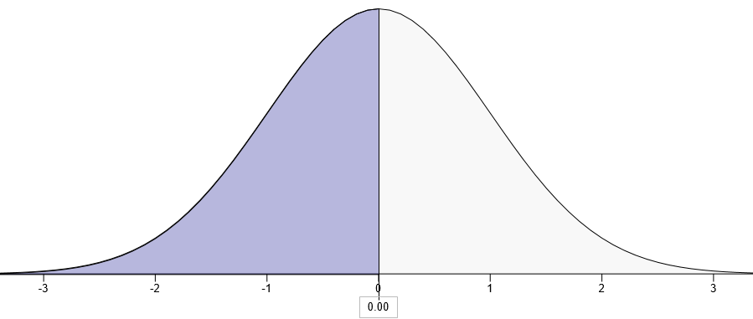  = 0.5 from Z table.  = 50%
d. | What percentage of terminals will last between 2.5 and 4.5 years?  P(2.5≤X≤4.5) = P((2.5-4)/0.83 ≤ (X-μ)/σ ≤ (4.5-4)/0.83  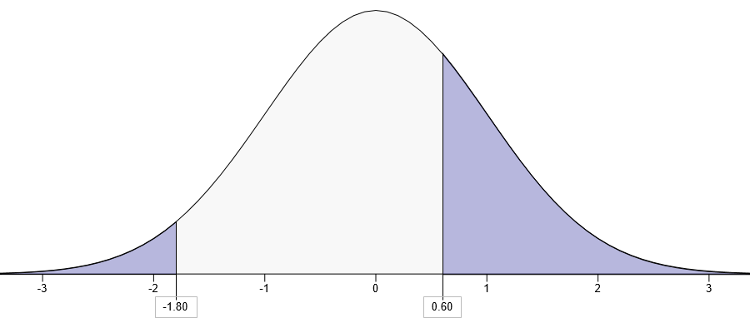  =P(-1.8072≤ Z≤ 0.6024  = P(Z≤ 0.6024) – P(Z≤ -1.8072)  = 0.7265 – 0.0354 From Z table  =0.6912  = 69.12%
e. | If the manufacturer guarantees the terminals for 3 years (and will replace them if they malfunction), what percentage of terminals will be replaced? Discuss.

P(X< 3) = P ((X-μ)/σ < (3-4)/0.83)
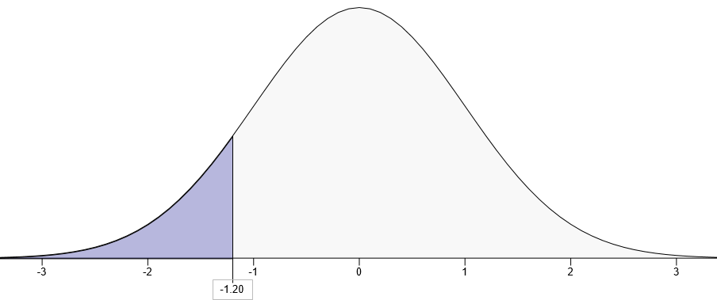
= P (Z<-1.2048)
= 0.1141
= 11.41%

--------------------------------------------------------------------------------------------------------------
Problem 5 Remember to show all work and briefly discuss your results. Sketch and shade region(s)
Show all work and discuss your results. Also sketch the region(s).
A professor at a local university noted that the exam grades of her students were normally distributed with a mean of 73 and a standard deviation of 11. Students who made 57.93 or lower on the exam failed the course. What percent of students failed the course?
P(X≤ 57.93) = P((57.93-73)/11)
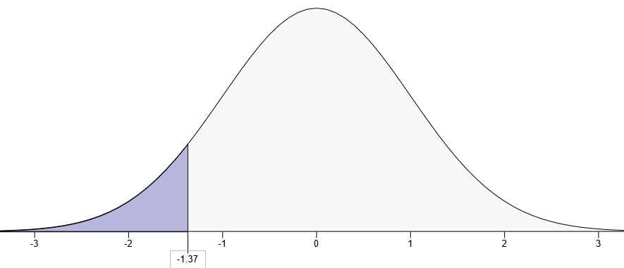
= P(Z ≤ -1.37) = 0.0853 From z table
= 8.53%
-----------------------------------------------------------------------------------------------------------
Problem 6 Remember to show all work and briefly discuss your results. Sketch and shade region(s)
The average starting salary of this year’s graduates of a large university (LU) is $20,000 with a standard deviation of $8,000. Furthermore, it is known that the starting salaries are normally distributed.
a. | What is the probability that a randomly selected LU graduate will have a starting salary of at least $30,400?  P (X ≥ 30400)  = P ((X-μ)/σ ≥ (30400-20000)/8000)  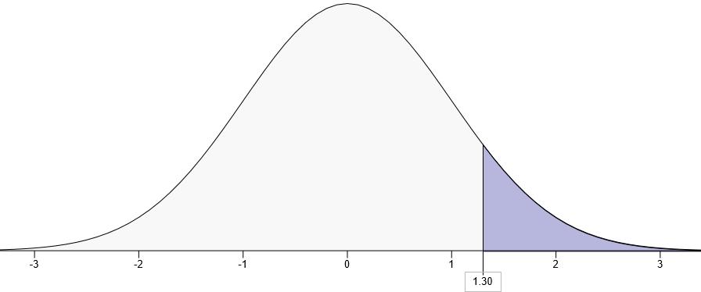  = P(Z ≥ 1.3 ) = 1- P (Z < 1.3)  = 1-0.9032 From z table  = 0.0968
b. | Individuals with starting salaries of less than $15,600 receive a low-income tax break. What percentage of the graduates will receive the tax break?  P (X< 15600) = P ((X-μ)/σ < (15600-20000)/8000)  = P (Z< -0.55)  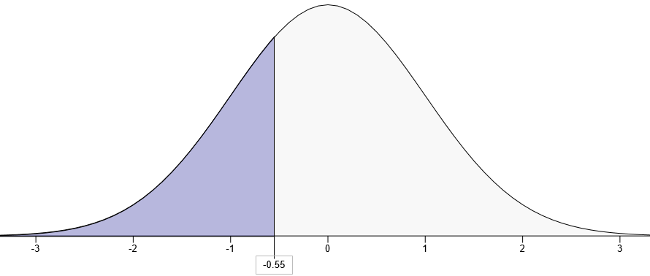  = 0.2912 From Z table  = 29.12%
c. | What are the minimum and the maximum starting salaries of the middle 95% of the LU graduates?  According to the empirical rule 95% of the data values are within 2 standard deviations of the mean.  = (20000- 2(8000), (20000+2(8000)  = [(20000-16000, (20000+16000)]  = (4000, 36000)  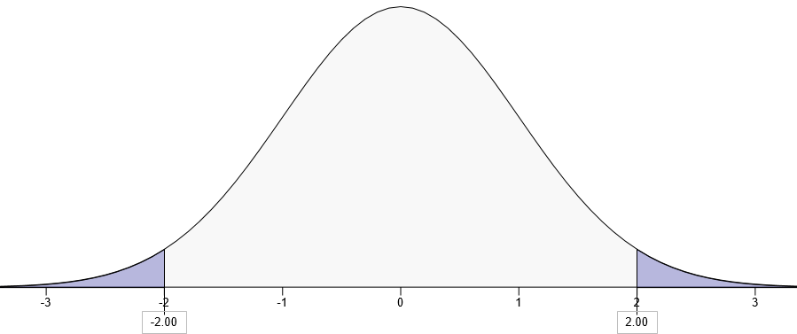
d. | If 189 of the recent graduates have salaries of at least $32,240, how many students graduated this year from this university?  Z = (32240-20000)/8000 = 1.53  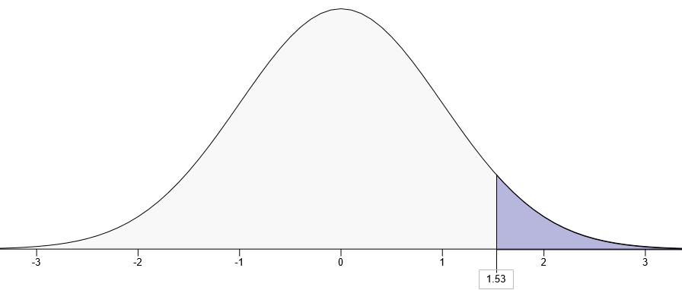  P(X ≥ 32240) = P (Z > 1.53)  = 1- P(Z < 1.53)  = 1 – 9370 = 0.0630 From Z table  The expected number is np  = 189*0.0630 = 11.907  ≈ 12 students

-------------------------------------------------------------------------------
Problem 8
Exhibit 6-9 Remember to show all work and briefly discuss your results.
The average price of personal computers manufactured by MNM Company is $1,200 with a standard deviation of $220. Furthermore, it is known that the computer prices manufactured by MNM are normally distributed.

- a. What is the probability that a randomly selected computer will have a price of at least $1,530?
- Solution
- Mean = $1200
- Standard deviation = $220
- Probability that price greater than $1530
- 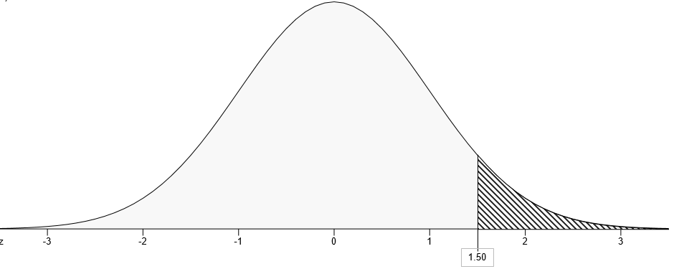
- Z-value = $\frac{1530-1200}{220}$
- = 1.5
- P-value = 1 – p(x<1530)
- P(x<1530) = 0.9332
- P(x>1530) = 1 – 0.9332
- = 0.0668
= 6.68%

- b. Computers with prices of more than $1,750 receive a discount. What percentage of the computers will receive the discount?
- Solution
- 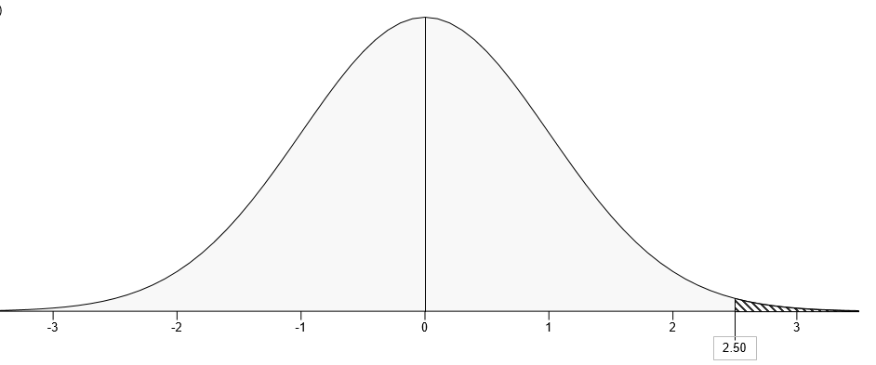
- P(x>1750) = 1 – p(x<1750)
- Z = $\frac{1750-1200}{220}$
- = 2.50
- P(x<1750) = 0.9938
- P(x>1750) = 1 – 0.9938
- = 0.0062
- = 0.62%

- c. What is the minimum value of the middle 95% of computer prices?
- Solution
- The lower value lies at 0.025
- The higher value lies at 0.975
- At 0.025 the z value = -1.96
- Using the formulae, z = $\frac{x-u}{sd}$
- -1.96 = $\frac{x-1200}{220}$
- X = -1.96(220) + 1200
- = 768.8
- At 0.975 z-value = 1.96
- 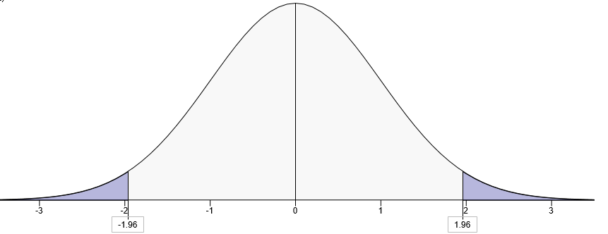
- X = 1.96(220) + 1200
- = 1631.2
- The price lies between; 768.8 < x < 1631.2
- For middle 95%, the minimum price is 768.8

- d. If 513 of the MNM computers were priced at or below $647.80, how many computers were produced by MNM?
- Solution
- Using the formulae, z = $\frac{x-u}{sd}$
- = $\frac{647.80-1200}{220}$
- = -2.51
- 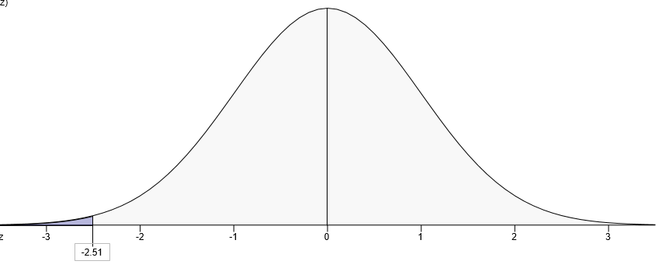
- P-value = 0.0060
- 513 = 0.0060
- ? = 1
- Number produced = $\frac{513}{0.0060} ×1$
- = 85500

---------------------------------------------------------------------------------------------------------------

Chapter 8
Problem 9 Remember to show all work and briefly discuss your results. Sketch and shade region(s)
The life expectancy in the United States is 75 with a standard deviation of 7 years. A random sample of 49 individuals is selected.
a. | What is the probability that the sample mean will be larger than 77 years?  Solution  Mean = 75  Standard deviation = 7  Sample (n) = 49  P(x> 77) = 1- p(x<77)  z-value = $\frac{77-75}{\frac{7}{\sqrt{49}}}$  = 2  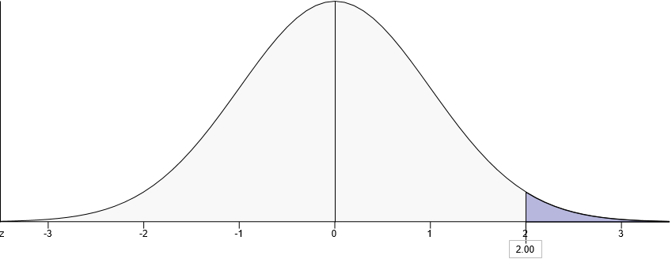 (x<77) = 0.9772  P(x> 77) = 1- 0.9772  = 0.0228
b. | What is the probability that the sample mean will be less than 72.7 years?  Solution  z-value = $\frac{72.7-75}{\frac{7}{\sqrt{49}}}$  = -2.3  p-value = 0.0107
c. | What is the probability that the sample mean will be between 73.5 and 76 years?  Solution  At 73.5,  z-value = $\frac{73.5-75}{\frac{7}{\sqrt{49}}}$  = -1.5  P(x< 73.5) = 0.0668  At 76,  z-value =$\frac{76-75}{\frac{7}{\sqrt{49}}}$  = 1  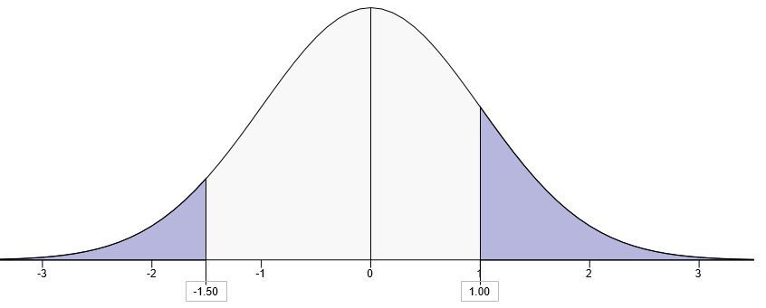  P(x< 76) = 0.8413  P(73.5<x<76) = 0.8413 – 0.0668  = 0.7745
d. | What is the probability that the sample mean will be between 72 and 74 years?  Solution  At 72,  z-value =$\frac{72-75}{\frac{7}{\sqrt{49}}}$  = -3  P(x< 72) = 0.0013  At 74,  z-value = $\frac{74-75}{\frac{7}{\sqrt{49}}}$  = -1  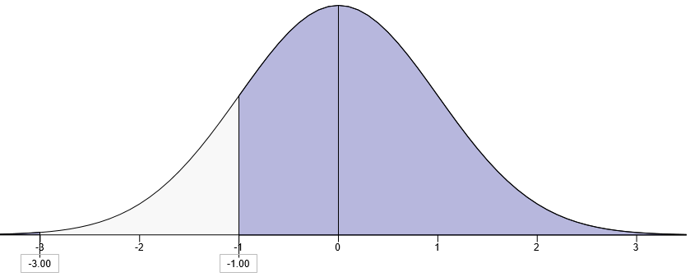  P(x< 74) = 0.1587  P(72<x<74) = 0.1587 – 0.0013  = 0.1574
e.  f. | What is the probability that the sample mean will be larger than 73.46 years?  Solution  z-value = $\frac{73.46-75}{\frac{7}{\sqrt{49}}}$  = -1.54  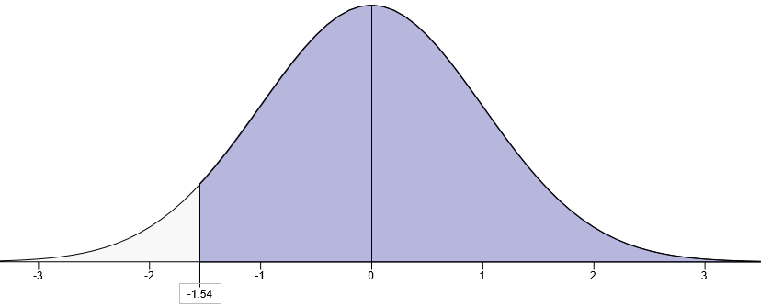  P(x< 73.46) = 0.0618  P(x>73.46) = 1 – 0.0618  = 0.9382  The standard error of the mean equals? What does it represent?  Standard error = $\frac{7}{\sqrt{49}}$  = 1  It represents the deviation of the values from the mean

------------------------------------------------------------------------------------------------------------------------
ProProblem 10 Remember to show all work and briefly discuss your results. Sketch and shade region(s)
The Mathematics part of the SAT scores of students at UTC are normally distributed with a mean of 500 and a standard deviation of 75.
​
a. | If 2.28 percent of the students who had the highest scores received scholarships, what was the minimum score among those who received scholarships?  Solution  Mean = 500  Standard deviation = 75  Percent = 2.28 (0.0228)  At this point p-value = 0.9772  z-value = 2.00  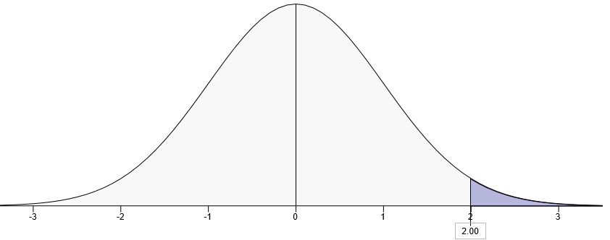  x = 2(75) + 500  x = 650  minimum score = 650
b. | It is known that 6.3 percent of students who applied to UTC were not accepted. What is the highest score of those who were denied acceptance?  Solution  Percent = 0.063  At 0.063, z-score = -1.53  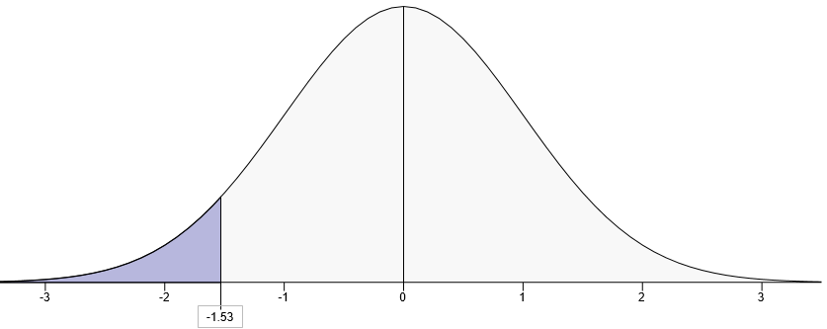  X = -1.53(75) + 500  = 385.25
c. | What percentage of students had scores between 575 and 650?  Solution  At 575,  z-score = $\frac{575-500}{75}$  = 1  p-value = 0.8413  at 650,  z-score = $\frac{650-500}{75}$  = 2  p-value = 0.9772  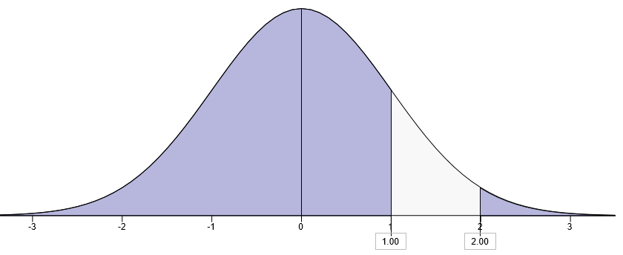  P(575<x<650) = 0.9772 – 0.8413  = 0.1359

Problem 11 Remember to show all work and briefly discuss your results. Sketch and shade region(s)
There are 8,000 students at the University of Tennessee at Chattanooga. The average age of all the students is 24 years with a standard deviation of 9 years. A random sample of 36 students is selected.
a. | Determine the standard error of the mean.  Standard error = $\frac{9}{\sqrt{36}}$  = 1.5
b. | What is the probability that the sample mean will be larger than 19.5?  z-score = (19.5 – 24) / 1.5  = -3  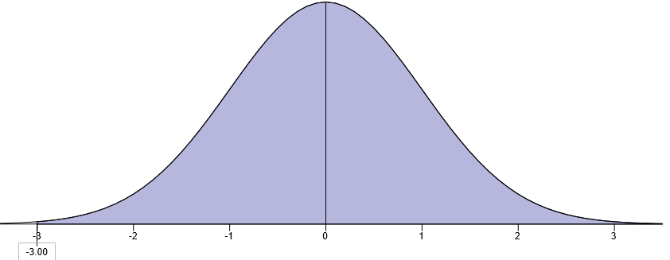  p-value = 1-0.0013  = 0.9987
c. | What is the probability that the sample mean will be between 25.5 and 27 years?  At 25,  Z -score = (25.5 – 24) / 1.5  = 1  p-value = .8413  at 27  z-score = (27-24) / 1.5  = 2  p-value = 0.9772  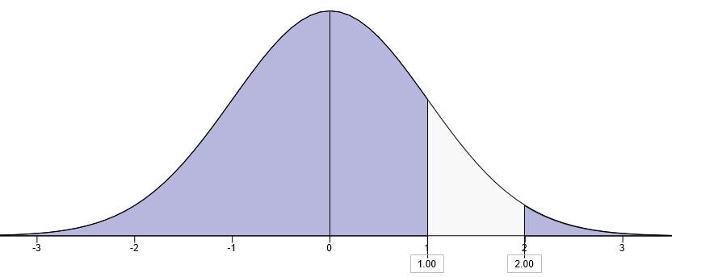

p-value = 0.9772 – 0.8413
= 0.1359
------------------------------------------------------------------------------
Problem 12 Remember to show all work and briefly discuss your results. Sketch and shade region(s)
In a large university, 20% of the students are business majors. A random sample of 100 students is selected, and their majors are recorded.
a. | Compute the standard error of the proportion.  Solution  Standard error = $\sqrt{\frac{pq}{n}}$  = $\sqrt{\frac{0.2×0.8}{100}}$  = 0.04
b. | What is the probability that the sample contains at least 12 business majors?  Solution  z-score=$\frac{0.12-0.2}{0.04}$  = -2  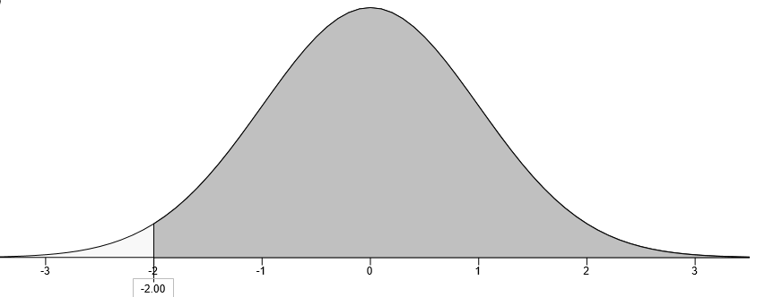  p-value = 0.0228  p(x>0.12) = 1 – 0.0228  = 0.9772
c. | What is the probability that the sample contains less than 15 business majors?  z-score=$\frac{0.15-0.2}{0.04}$  = -1.25  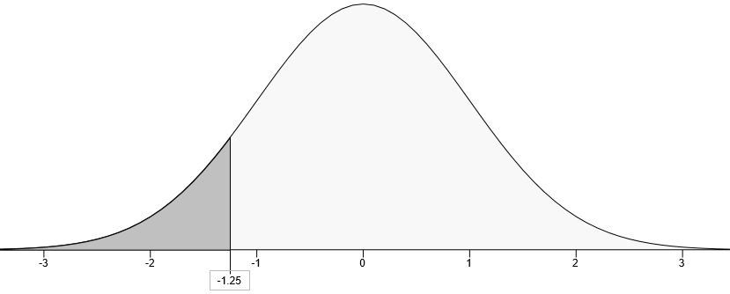  P(x<0.15) = 0.1056
d. | What is the probability that the sample contains between 12 and 14 business majors?  Solution  At 12, p-value = 0.0228  At 14, z-score = $\frac{0.14-0.2}{0.04}$  = -1.5  p-value = 0.0668  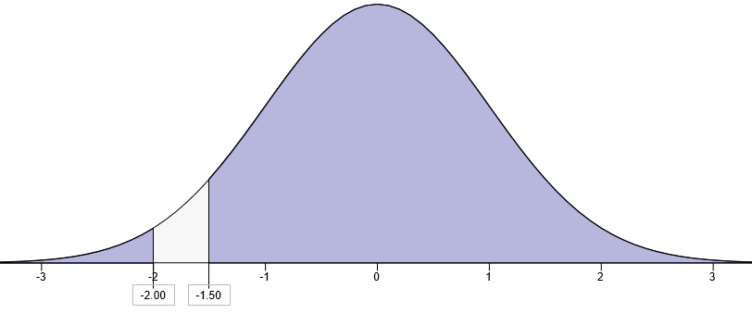  p(0.12<p<0.14) = 0.0668 – 0.0228  = 0.044

Essays (20%): Complete ANY THREE the following essays and provide real examples and your own opinions. Each essay should be at least one side of one page in length single spaced. It is important to provide examples and your opinion beyond textbook definitions.
- Social networking sites support themselves in large part by selling advertising space. The hit rate on these ads is a critical measure when trying to solicit advertising. The hit rate is used as a measure of success for ads. How would you recommend a social networking site use statistical sampling to evaluate its existing ads? Give a specific example and provide your opinion.
- Descriptive statistics introduces the use of graphs and charts. This is probability the most common form of statistics that is about everywhere out there in terms of visual displays. Do you feel this is the best way to visualize it or would you recommend another form of descriptive statistic and if so what?
Solution
I would recommend the use of descriptive statistics to visualize distribution of the data. Descriptive statistics gives us an easy and quick over view of the data. It is simple to carry and interpret. However, other descriptive statistics such as calculation of exact values such as mean and standard deviation should be incorporated to support graphical presentation.

- Central Tendencies and variation like the mean, median, mode, variance and standard deviation. These are for example very commonly used in standardized exam scores such as the SAT, CPA, LSAT or GRE, or GMAT. Can you come up with another example of how one of more of these are used in the real world citing a specific example and provide a pro and con.
Solution
These central tendencies are used in medical field to state the spread of a disease. For example, world health organization estimates that mean cancer cases reported in Africa per year are 700,000. Mode is also used to report the majority of people affected by certain disease. For example, women are more affected by cancer than men.

- Continuous Random Variables discusses the importance of the Normal Probability Distribution or area under the curve. This is a very important topic when it comes to evaluating areas under the curve and statistics as a whole. Once something falls into the normal distribution area we can calculate those probabilities. This important concept tries to determine if it is a two tail or one tail distribution as well as its skew (shape of graph). Can you come up with a real-world example and briefly discuss your thoughts about this?
Solution
We can be concerned by checking if salary of men is equal to that of women. In this case we are testing for equality of the mean salary for the two groups therefore we use to tail test. However, we can research on whether the mean salary of men is greater that of women. In this case we per form one tailed test.

